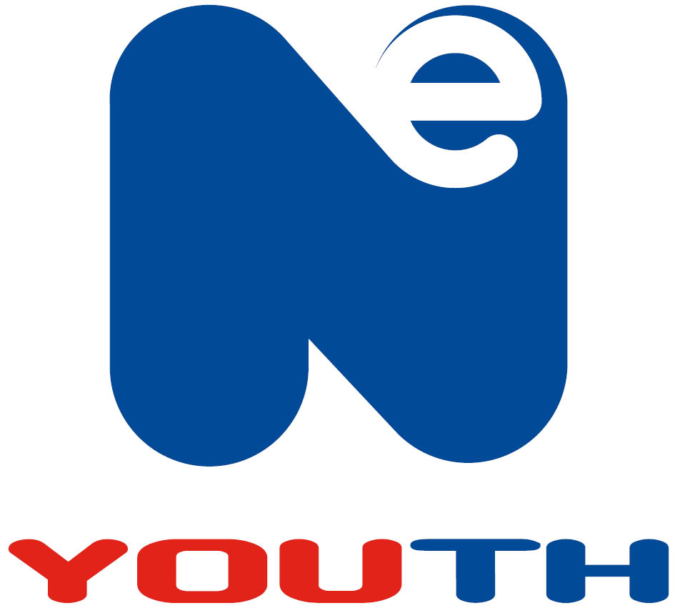

C O N F I D E N T I A L

NOMINATION FOR KEYSTONE AWARD
IN RECOGNITION OF VOLUNTARY SERVICE

BRONZE - 10 YEARS / SILVER - 20 YEARS / GOLD - 30 YEARS / PLATINUM – 40 YEARS /

PRESIDENT’S – 50 YEARS

PART A – To be completed by nominating club

NAME_______________________________________________________
(Block capitals please – and as you wish the name to appear on the certificate)

ADDRESS__________________________________________________________________

NAME OF ORGANISATION ______________________________________

DATES OF VOLUNTARY SERVICE from____ to ___

Details of voluntary service to your organisation, together with any special comments, circumstances and positions held.

Signed …………………. Position …………….. Date………………

PART B – To be completed by the Member Organisation and forwarded to NE Youth, The New Inn, Bridge Street, NE21 4JJ. Email: olivia@neyouth.org.uk

We recommend that _ _______ is awarded a ______________________
(Please insert as applicable: President’s-50 years; Platinum-40 years; Gold-30 years;
Silver-20 years; Bronze-10 years)
Signed _______________________________________________ (Chairman)

Member Organisation_______________________________

Certificate required for presentation on ________________________ (insert date)

Please give as much notice as possible when requesting certificates.

KEYSTONE AWARDS
IN RECOGNITION OF VOLUNTARY SERVICE

The following points are set out for guidance:-

- Submissions, if initiated at club level, must be channeled through NE Youth.

- Submissions, to be successful, must be fully supported by the Member Organisation.

- A person who has retired and no longer provides voluntary service is still eligible provided he/she has completed the requisite number of year’s voluntary service in the past.

- The years counting towards the award must be of service within the organisation. Someone, who has completed 9 years with the Organisation and a number of earlier years with, say, the Boy Scouts would not be eligible until a further year’s service to the organisation had been completed.

- If a person has been a volunteer with a club for a large number of years but the club has only been affiliated to NE Youth for less than 10 years he/she will not be eligible.

- It does not matter who signs the submission on behalf of the club provided as long as it has the support of the Member Organisation.

