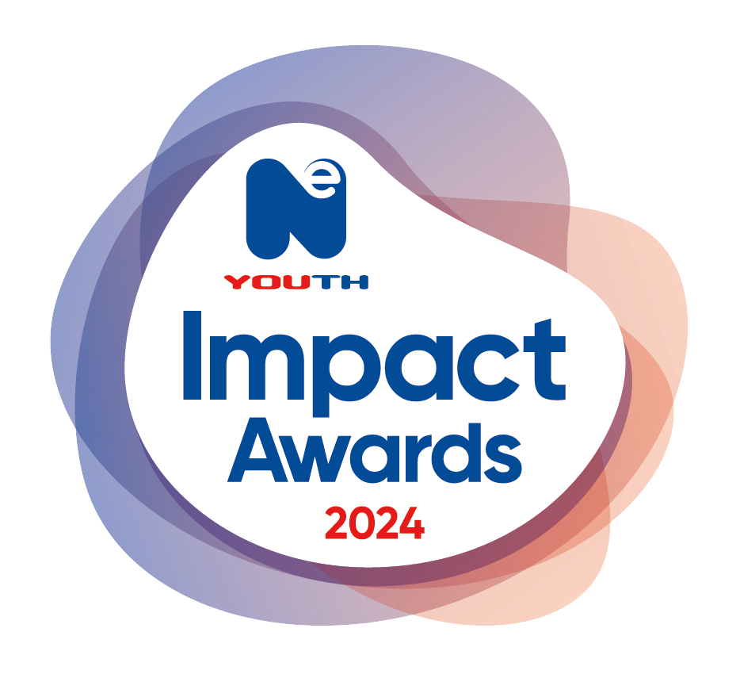
Making a positive difference to the lives of young people

NE Youth Impact Awards 2024

Our NE Youth Impact Awards are about celebrating and recognising the achievements and talents of our member organisations (including their young people, staff and volunteers) over the previous year.

There will be 15 award categories this year and you can enter what you consider to be the best examples from your organisation for each category.

Criteria – Please ensure you read all criteria provided.

Judging – An independent judging panel will meet on W/C 14th October to assess all eligible nomination forms.

Closing Date – Please complete and submit your nomination form, using this link NE Youth Impact Awards 2024 - NE Youth for all your entries.

The deadline for return of all nomination forms (including pictures and supporting evidence) is: 11.55pm on the 13th October 2024.

Announcement of the Winners – We will announce the winners at our NE Youth Impact Awards Ceremony on Wednesday 6th November 2024.

All nominees will receive a certificate and winners will also receive a trophy.

Remember, please provide a photo with all entries which we can use in our presentation at the event. (Please make sure that you have obtained appropriate photo consent for a third party to use submitted images).

The awards are open to all young people and staff/volunteers aged 11+ who are involved in your organisation.

Awards Criteria

Categories:

- Project of the Year  - Young Achiever of the Year  - Young Volunteer of the Year  - Volunteer of the Year  - Youth Worker of the Year  - Most Improved of the Year (Project or Organisation)  - Going Green Award | - Sports, Leisure and Culture of the Year  - Social Action of the Year  - Partnership of the Year  - Trustee of the Year  - The Nigel Voules Keystone Award (see separate form)  - NE Youth Member of the Year  - Community Champion of the Year  - Mentor of the Year

AWARD | CRITERIA
Project of the Year | Open to projects or organisations of any size that can demonstrate the outstanding impact and opportunities they have achieved with and for young people. This can be through direct work and through projects that promote and demonstrate a community wide impact to benefit young people in your area or beyond.
Young Achiever of the Year | Nominations should be for a young person (under 18 years old) who has demonstrated a strong commitment to self-improvement and development. Achievements can be formal, informal or a combination of both. We are hoping to see diverse examples of young people who have developed skills and knowledge and/or who have made a positive contribution to others within their local community. Nominees may have also overcome personal barriers and achieved milestones that are worthy of recognition.
Young Volunteer of the Year | Nominations should demonstrate the outstanding contributions of the young volunteer (under 18 years old) and the impact that this has had. The individual should have contributed above and beyond what is expected of them in their role or inspired change, innovation or improvements regarding how things are done. The nominee may be a role model to other young people and demonstrates the positive impact young people can have on programmes, projects and their community.
Volunteer of the Year | Nominations should demonstrate the outstanding contributions of the volunteer (18 years and over) and the impact that this has had. The individual should have contributed above and beyond what is expected of them in their role or inspired change, innovation or improvements regarding how things are done. This individual may also advocate for the rights of a young person(s) and demonstrate a work ethos that encourages and promotes youth voice. All volunteer nominations may be eligible for the Nigel Voules Keystone award.
Youth Worker of the Year | Nominations should demonstrate the contribution the individual has made in relation to the improvement of practice or outcomes, examples of them going above and beyond in their roles to ensure positive results for young people, or who have been instrumental in the development of an excellent example of youth participation work. Nominations may also demonstrate effective youth voice practise and actively support and encourage young people to learn, develop and achieve through their approach, creativity and adaptability.
Most Improved of the Year (Project or Organisation) | This award recognises significant improvement in a project or organisation, for example: through an increase in numbers, the development of a diverse programme, growth or sustainability, taking part in community action or being involved in creative activities, etc. Nominations for this award can be your organisation or projects success/achievements that you feel deserves recognition for the impact it has had.
Going Green Award | To reflect on NE Youth’s commitment and pledge to adopting greener working practices, this award recognises an organisation’s ongoing dedication to making and encouraging positive environmental change. This may be through: day to day working procedures, projects with young people and the wider community, making positive environmental changes, delivering educational sessions, developing initiatives for staff and young people etc. Nominations for this award can be for anything you feel demonstrates a pro-active approach to a ‘greener working’ strategy.
Sports, Leisure and Culture of the Year | This award is for an organisation or an individual who has had a significant impact on the lives of others. Helping and supporting others to engage in sports, leisure and culture activities that helps to improve health and wellbeing and enrich people’s lives. All leisure, culture and heritage activities are eligible. Nominations could outline and showcase the positive impact sport, leisure and culture has had on the participants and the positive achievements individuals or groups may have had from participating in your sessions/projects.
Social Action of the Year | We are looking for projects which are youth led, impactful, creative and innovative which demonstrate sustainability where possible. This may be instigated from youth voice or driven by young people to create a project, programme or event that is designed to benefit young people and/or the wider community.
Partnership of the Year | To reflect NE Youth’s ongoing commitment to ensuring good quality collaboration and partnership working, we are looking for examples of work which have been successful due to new and/or improved partnership working. The judges will be looking for examples of how partnership working has added value to services/project(s) and how this has had a positive impact for young people. Nominations may also outline why the partnership was developed and the outcomes this has had throughout the past year.
Trustee of the Year | Nominations should demonstrate the outstanding contribution of a trustee in relation to their role. The individual should have inspired development and/or change for the organisation or helped to make a significant contribution to strengthening governance arrangements and quality. This nomination may also go above and beyond to support growth, expansion, sustainability, staff, volunteers and the young people accessing the service and/or help introduce positive changes to the organisation and its culture. All trustee nominations may also be eligible for The Nigel Voules Keystone award.
NE Youth Member of the Year | To reflect on NE Youth’s commitment to partnership working and our member network, this award has been created to recognise an organisation’s ongoing involvement, participation and engagement with NE Youth’s offer and services. Nominations may: take part in monthly competitions, be actively involved in NE Youth’s monthly members meetings, access NE Youth’s services and programmes, work in collaboration with NE Youth, take part in NE Youth’s events and offers, access training opportunities and workforce development through the North East Youth Alliance, supported fellow members through networking and partnership work, provided opportunities for NE Youth and/or other NE Youth members, etc.
Community Champion of the Year | To reflect on an individual's ongoing commitment to enhancing their local community, this award has been created to showcase the significant impact an individual has had through their direct work/volunteering in a local area. A community champion may be viewed as a community asset, respected by community members and somebody who goes above and beyond to bring positive outcomes to those who reside in a community they work in. This may be through work such as: creating opportunities, promoting and supporting wellness, enhancing opportunities and/or improving the quality of life of residents. Nominations for this award should outline why you believe a community would not be the same without this individual, and the positive impact they have made over the last 12 months.
Mentor of the Year | Open to any mentor whether that be an apprenticeship mentor, work mentor, peer-mentor or mentor to young people etc. Nominations should demonstrate how they have inspired, motivated or encouraged their mentees in their personal and/or professional development. The award recognises the commitment the nominated mentors have to being a mentor, the outstanding effort put into their work, and the significant impact they have made to their mentee's development.

